Lampiran 7. Hasil Uji Normalitas
- Motivasi Menghafal Alquran
Case Processing Summary
 | Cases
 | Valid |  | Missing |  | Total
 | N | Percent | N | Percent | N | Percent
MotivasiMenghafalAlquran | 87 | 100,0% | 0 | 0,0% | 87 | 100,0%

Descriptives
 |  |  | Statistic | Std. Error
MotivasiMenghafalAlquran | Mean |  | 181,72 | 1,759
MotivasiMenghafalAlquran | 95% Confidence Interval for Mean | Lower Bound | 178,23
MotivasiMenghafalAlquran | 95% Confidence Interval for Mean | Upper Bound | 185,22
MotivasiMenghafalAlquran | 5% Trimmed Mean |  | 182,83
MotivasiMenghafalAlquran | Median |  | 184,00
MotivasiMenghafalAlquran | Variance |  | 269,156
MotivasiMenghafalAlquran | Std. Deviation |  | 16,406
MotivasiMenghafalAlquran | Minimum |  | 121
MotivasiMenghafalAlquran | Maximum |  | 211
MotivasiMenghafalAlquran | Range |  | 90
MotivasiMenghafalAlquran | Interquartile Range |  | 16
MotivasiMenghafalAlquran | Skewness |  | -1,210 | ,258
MotivasiMenghafalAlquran | Kurtosis |  | 2,913 | ,511

Tests of Normality
 | Kolmogorov-Smirnovª |  |  | Shapiro-Wilk
 | Statistic | df | Sig. | Statistic | df | Sig.
MotivasiMenghafalAlquran | ,122 | 87 | ,003 | ,922 | 87 | ,000
a. Lilliefors Significance Correction

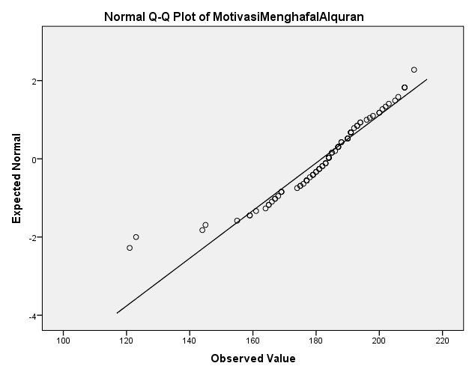

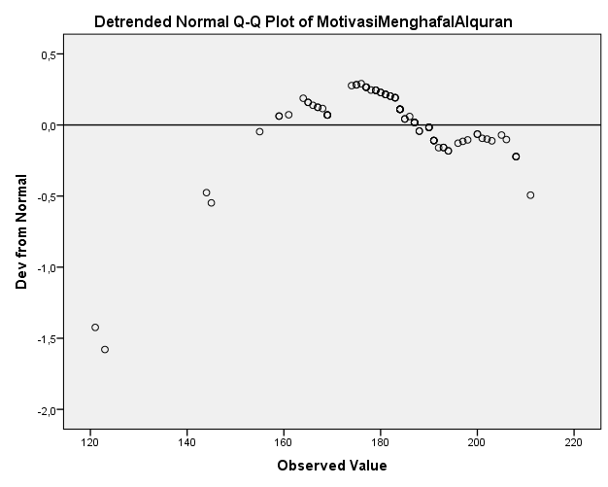

- Efikasi Diri
Case Processing Summary
 | Cases
 | Valid |  | Missing |  | Total
 | N | Percent | N | Percent | N | Percent
EfikasiDiri | 87 | 100,0% | 0 | 0,0% | 87 | 100,0%

Descriptives
 |  |  | Statistic | Std. Error
EfikasiDiri | Mean |  | 136,40 | 1,735
EfikasiDiri | 95% Confidence Interval for Mean | Lower Bound | 132,95
EfikasiDiri | 95% Confidence Interval for Mean | Upper Bound | 139,85
EfikasiDiri | 5% Trimmed Mean |  | 137,56
EfikasiDiri | Median |  | 139,00
EfikasiDiri | Variance |  | 261,848
EfikasiDiri | Std. Deviation |  | 16,182
EfikasiDiri | Minimum |  | 71
EfikasiDiri | Maximum |  | 174
EfikasiDiri | Range |  | 103
EfikasiDiri | Interquartile Range |  | 16
EfikasiDiri | Skewness |  | -1,403 | ,258
EfikasiDiri | Kurtosis |  | 3,933 | ,511

Tests of Normality
 | Kolmogorov-Smirnovª |  |  | Shapiro-Wilk
 | Statistic | df | Sig. | Statistic | df | Sig.
EfikasiDiri | ,131 | 87 | ,001 | ,903 | 87 | ,000
a. Lilliefors Significance Correction
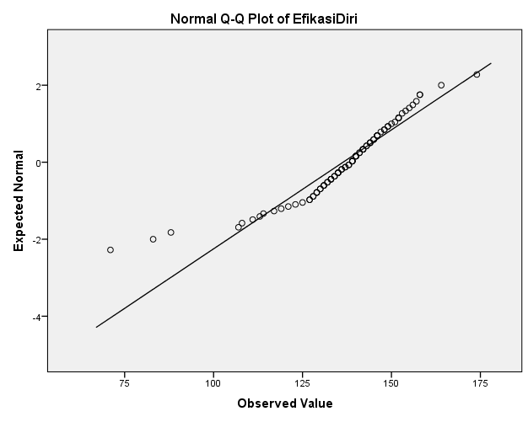
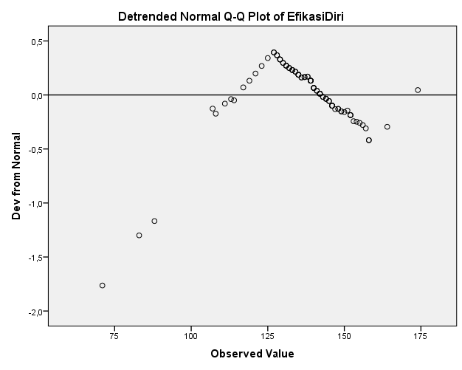
- Dukungan Guru Tahfidz
Case Processing Summary
 | Cases
 | Valid |  | Missing |  | Total
 | N | Percent | N | Percent | N | Percent
DukunganGuruTahfidz | 87 | 100,0% | 0 | 0,0% | 87 | 100,0%

Descriptives
 |  |  | Statistic | Std. Error
DukunganGuruTahfidz | Mean |  | 118,74 | 1,413
DukunganGuruTahfidz | 95% Confidence Interval for Mean | Lower Bound | 115,93
DukunganGuruTahfidz | 95% Confidence Interval for Mean | Upper Bound | 121,55
DukunganGuruTahfidz | 5% Trimmed Mean |  | 119,09
DukunganGuruTahfidz | Median |  | 117,00
DukunganGuruTahfidz | Variance |  | 173,801
DukunganGuruTahfidz | Std. Deviation |  | 13,183
DukunganGuruTahfidz | Minimum |  | 81
DukunganGuruTahfidz | Maximum |  | 147
DukunganGuruTahfidz | Range |  | 66
DukunganGuruTahfidz | Interquartile Range |  | 17
DukunganGuruTahfidz | Skewness |  | -,288 | ,258
DukunganGuruTahfidz | Kurtosis |  | ,382 | ,511

Tests of Normality
 | Kolmogorov-Smirnovª |  |  | Shapiro-Wilk
 | Statistic | df | Sig. | Statistic | df | Sig.
DukunganGuruTahfidz | ,108 | 87 | ,013 | ,962 | 87 | ,012
a. Lilliefors Significance Correction
